Heatwave social media copy
Hospital services are currently very busy due to extreme heat, pollen levels and strike action.  Older people are particularly at risk of becoming unwell during a heatwave.  Find out more about how to keep safe: https://www.southwestlondon.icb.nhs.uk/news/nhs-issues-heatwave-warning-for-older-people-and-people-with-asthma/ | 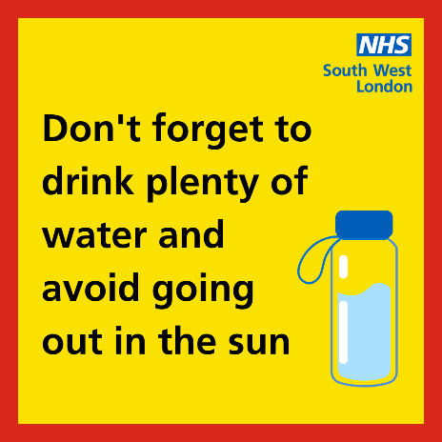
As well as being very hot, pollen and pollution levels are very high in London today and hospital services are currently very busy.  If you have to go outside, stay in the shade especially between 11am and 3pm, and avoid exercise or activity that makes you hotter.  Find out more about how to keep safe: https://www.southwestlondon.icb.nhs.uk/news/nhs-issues-heatwave-warning-for-older-people-and-people-with-asthma/ | 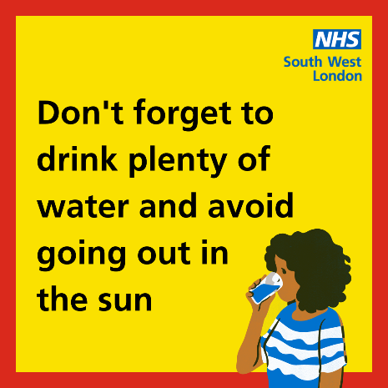
Hospital services are currently very busy due to extreme heat, pollen, pollution levels and strike action.  If you, or your child, has asthma or other respiratory conditions, please remember to take your medication.  Find out more about how to keep safe: https://www.southwestlondon.icb.nhs.uk/news/nhs-issues-heatwave-warning-for-older-people-and-people-with-asthma/ | 