Mental health services in south west London – Talking Therapies and Recovery Cafes
Key messages
- Key message - If you need support for your mental health, there are a range of free and confidential NHS services available in south west London. Find out more, search ‘South West London Mental Health’.
- Mental Health Awareness Week - To mark Mental Health Awareness Week (Monday 15 - Sunday 21 May 2023), we are reminding local people of the free mental health support services available. If you or someone you know is struggling, seek help today. Find out more, search ‘SWL Mental Health’

Example asset | Supporting copy
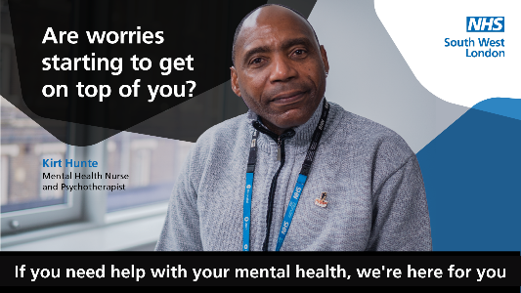 | It’s okay not to be okay and support is available for whatever you’re going through. From talking therapies to recovery cafes, find out what NHS mental health services are available to you: [insert link]
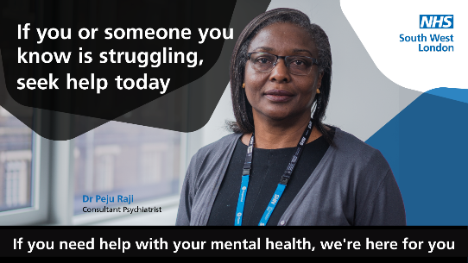 | Feelings of anxiety, depression or stress can affect us all. If you need help with your mental health, there are a range of local NHS services ready to help you. Find out more: [insert link]

