Easter Bank Holiday 2023
Social media messages

Asset | Copy
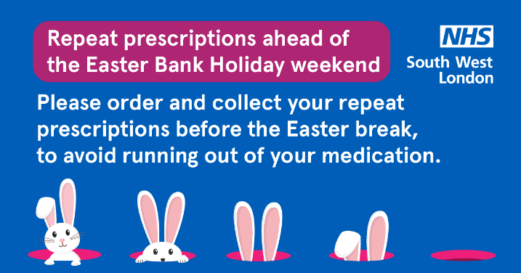 | 📣 Do you take medication regularly?  ⌛ It is important to check your prescription and order what you need in plenty of time.
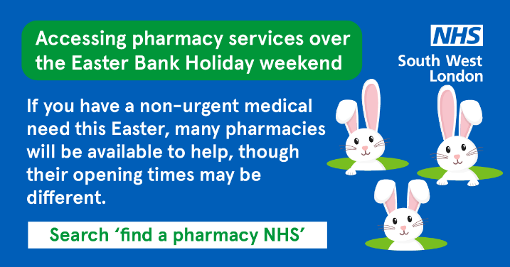 | Your local pharmacy can offer healthcare services and you don’t need to book an appointment. Find a pharmacy near you this Easter 🐰 http://ow.ly/7YVX50NvFy7
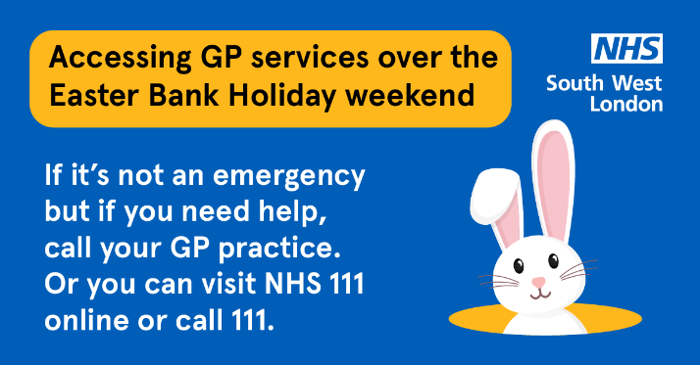 | Need medical help over the Easter Bank Holiday? 🚨 Remember A&E and 999 are for emergencies, call your GP or use NHS 111 if you need urgent help that’s not life threatening: https://111.nhs.uk/

