Copy | Asset
📣 Do you take medication regularly?  ⌛ It is important to check your prescription and order what you need and in plenty of time | 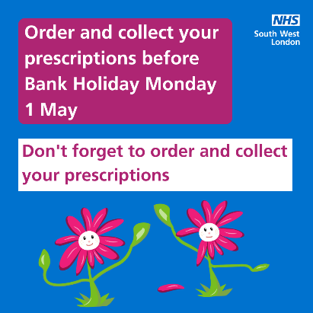
Your local Pharmacy offers healthcare services which you don't need to book an appointment for, just pop in.  Find out if your local pharmacy is open this bank holiday👉 ow.ly/h1d650wZ9w0 | 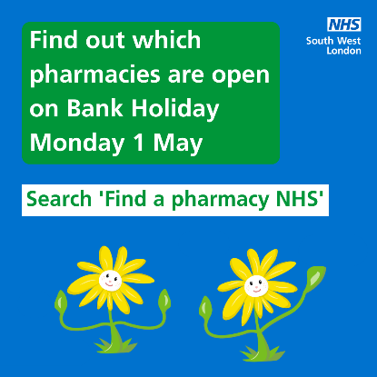
Need medical help over the May bank holiday?  🚨 Remember A&E and 999 are for emergencies https://111.nhs.uk/ | 