Copy​ | Assets​
🤔 Want to check whether you are registered for organ donations?  You can use the NHS App to:  ✅ Check your registered decision  ✅ Choose to donate some or all of your organs  Download the #NHSApp now 👇  https://www.nhs.uk/using-the-nhs/nhs-services/the-nhs-app/ | ​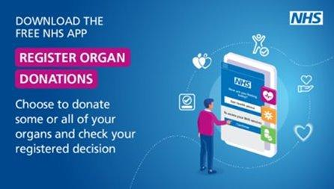  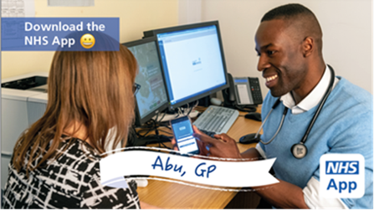
🙌 The NHS App gives you 24/7 access to a range of NHS services all in one place:  ✅ Access your COVID Pass  ✅ Order repeat prescriptions  ✅ View your health records  Download the #NHSApp now 👇  https://www.nhs.uk/using-the-nhs/nhs-services/the-nhs-app/ | 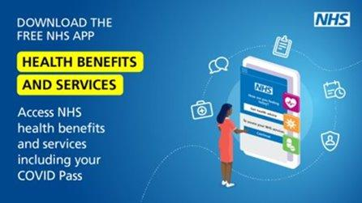  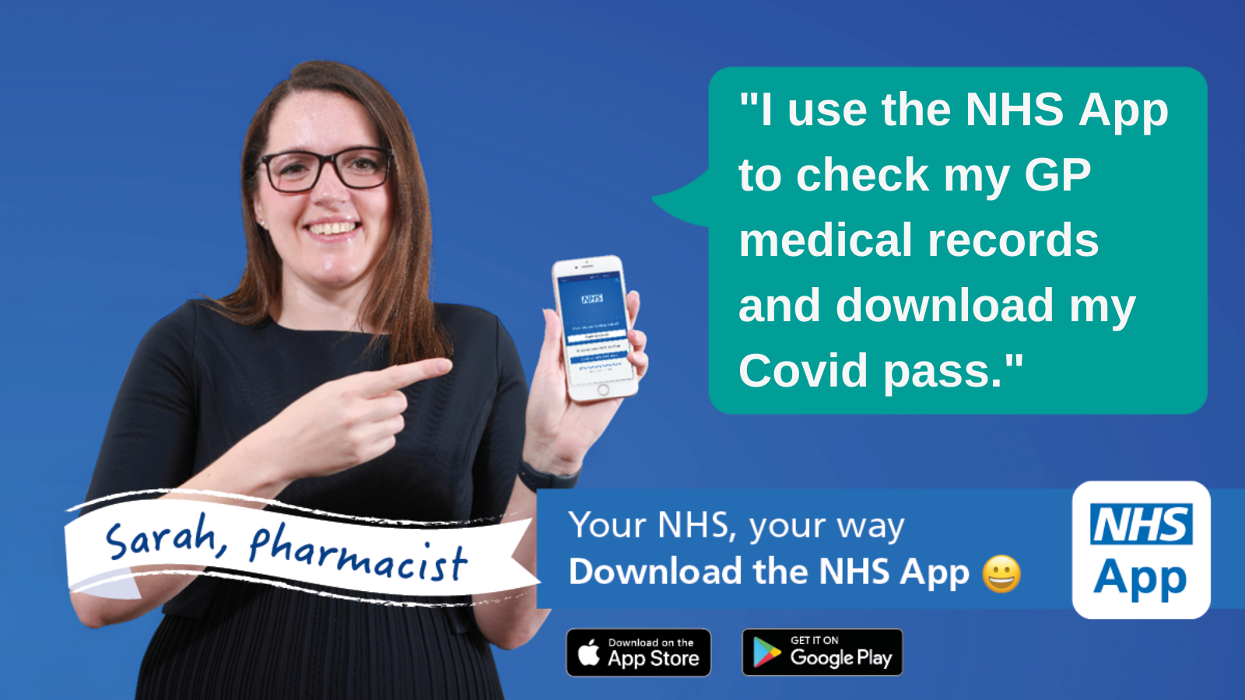
💊 Did you know that you can use the NHS App to order your repeat prescriptions?  ✅ Request a new repeat prescription  ✅ Choose which pharmacy to collect from  Download the #NHSApp now 👇  https://www.nhs.uk/using-the-nhs/nhs-services/the-nhs-app/ | 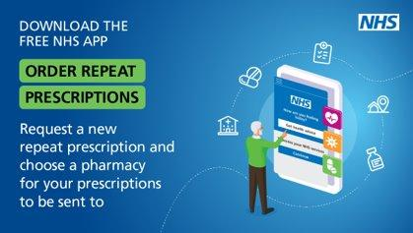  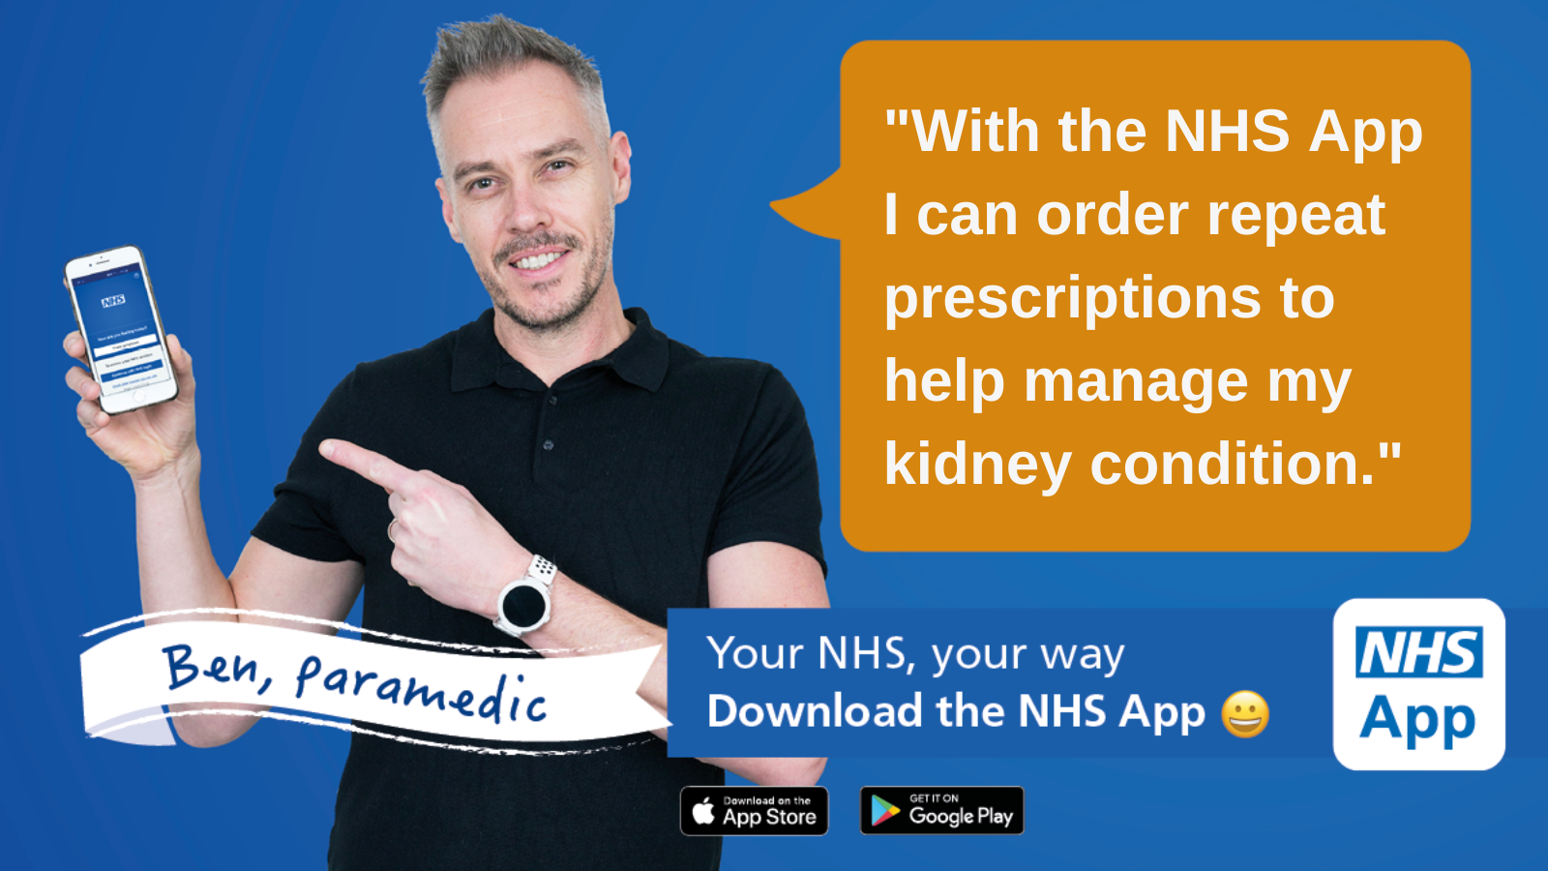
✅ Need to prove your COVID vaccination status?  📲 You can access your COVID Pass on the free NHS App!  Download the #NHSApp now 👇  https://www.nhs.uk/using-the-nhs/nhs-services/the-nhs-app/ | 