Message | Example asset | Supporting copy
Mental Health Crisis (Wandsworth, Merton, Sutton, Kingston, Richmond) | 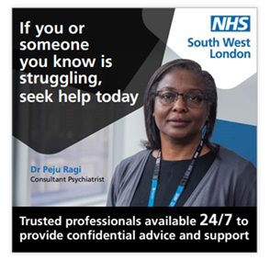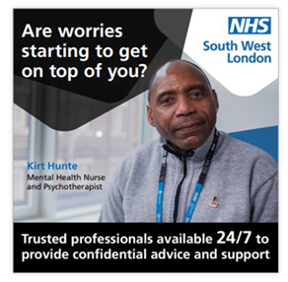 | If you need urgent mental health support, call our 24/7 Mental Health Crisis Line team. They are there to help you.  🚨 Please only attend A&E if it is an emergency.  Click to find out more www.swlstg.nhs.uk/patients-carers/crisis-support/mental-health-support-line
Mental health crisis (Croydon) |  | If you need urgent mental health support, call our 24/7 Mental Health Crisis Line team. They are there to help you.  🚨 Please only attend A&E if it is an emergency.  Click to find out more https://slam.nhs.uk/crisis
Kooth (all of SWL) | 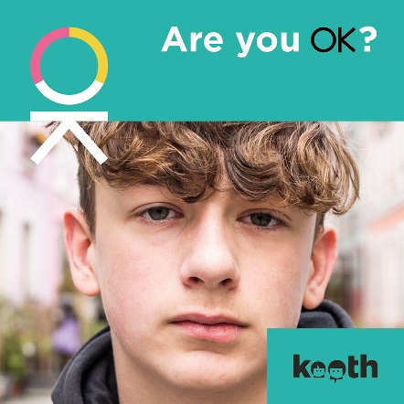 | If you are 11-22 years old and are feeling anxious or low, you can speak to someone online for support 24/7.  Find out more 👉 https://kooth.com

