Zero tolerance campaign

social media copy

Twitter posts | Image example
We have the right to refuse treatment and take further action against anyone who threatens the safety of our staff and our patients. Abuse is #NotInADaysWork | 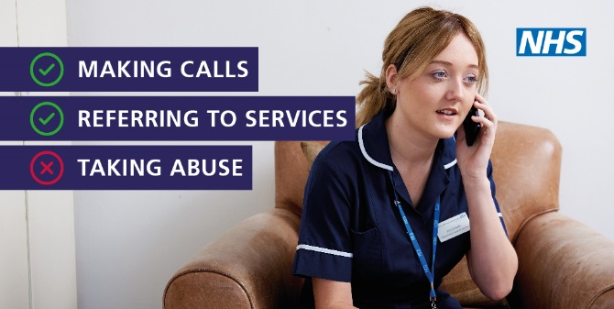
Dealing with people who are abusive or aggressive towards our staff and our patients, takes us away from caring for you. Let’s work together to ensure abuse and aggression is #NotInADaysWork | 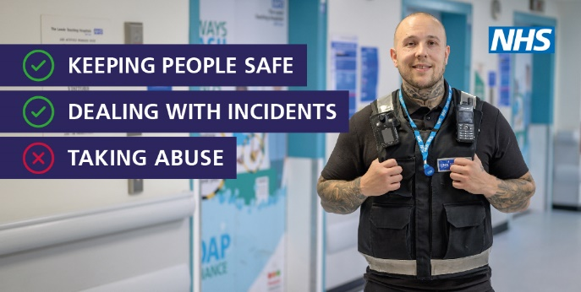
Let’s make sure BOROUGH continues to be a great place for our staff and our patients to live and be cared for. To do this we want to stop any abuse or aggression towards our staff and our patients. #NotInADaysWork | 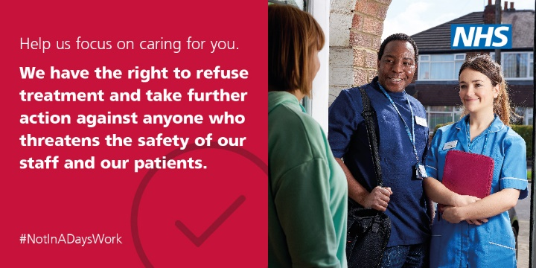
Taking care  X Taking abuse  Help us focus on caring for you. We have a zero tolerance approach to abuse and violence against our staff and patients. #NotInADaysWork | 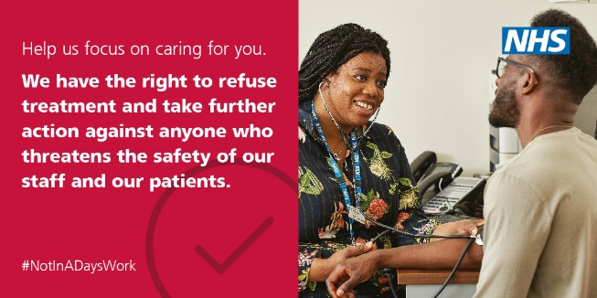
We want to create a safe environment for our staff and patients, you can help us do this. The NHS in BOROUGH is taking a zero tolerance approach to abuse and aggression towards our staff and our patients join us and say this is #NotInADaysWork | 